1. Write a Python program to sum all the items in a list’

p

**Code:**

total = 0

# creating a list

list1 = [11, 5, 17, 18, 23,20,23,50,40]

for ele in range(0, len(list1)):

total = total + list1[ele]

# printing total value

print("Sum of all elements in given list: ", total)

**Output:**



1. **Write a Python program to multiply all the items in a list.**

**Code:**

def multiplyList(myList) :

result = 1

for x in myList:

result = result * x

return result

list1 = [1, 2, 3,5,6]

print("multiple of list",multiplyList(list1))

**Output:**



1. **Write a Python program to get the largest and the smallest number from a list.**

**Code:**

list=[10,20,30,80,8]

elmt = list[ 0 ]

elmt2 = list[ 0 ]

for a in list:

if a < elmt:

elmt = a

for b in list:

if b > elmt2:

elmt2 = b

print("smallest element is : ",elmt)

print("maximum element is : ",elmt2)

**Output**:

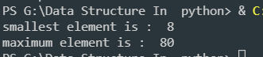

1. **Write a Python program to count the number of strings where the string length is 2 or more and the first and last character are same from a given list of strings.**

**Code:**

def func(strings) :

count = 0;

for string in strings:

if string[0] == string[len(string) - 1] and len(string) >= 2:

count += 1;

return count;

print(func(["HH", "HeelH", "D","AytA"]))

**Output:**



1. **Write a Python program to get a list, sorted in increasing order by the last element in**

**each tuple from a given list of non-empty tuples.   
Sample List : [(2, 5), (1, 2), (4, 4), (2, 3), (2, 1)]  
Expected Result : [(2, 1), (1, 2), (2, 3), (4, 4), (2, 5)]**

**Code:**

def last(n):

return n[-1]

def sort(list):

return sorted(list, key=last)

a=[(2, 5), (1, 2), (4, 4), (2, 3), (2, 1)]

print("Sorted:")

print(sort(a))

**Output:**

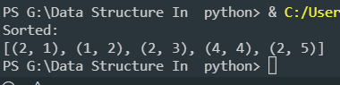

1. **Write a Python program to remove duplicates from a list.**

**Code:**

def Remove(duplicate):

list = []

for num in duplicate:

if num not in list:

list.append(num)

return list

duplicate = [2, 4, 10, 20, 5, 2, 20, 4,20,5,21]

print(Remove(duplicate))

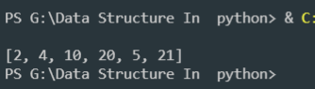**Output:**

1. **Write a Program to find the sum of all numbers stored in a list.**

**Code:**

total = 0

lst=[]

lst_size= int(input("enter the size of list: "))

def list_entries(nlist,n):

for i in range(n):

val= int(input("enter value: "))

nlist.append(val)

print("list is : ",nlist)

list_entries(lst,lst_size)

for ele in range(0, len(lst)):

total = total + lst[ele]

print("Sum of all elements in given list: ", total)

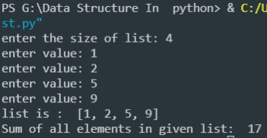**Output:**

1. **Write a Program to Reverse a  five digit given integer number**

**Code:**

n = 4562

rev = 0

while(n > 0):

a = n % 10

rev = rev * 10 + a

n = n // 10

print(rev)

**Output:**

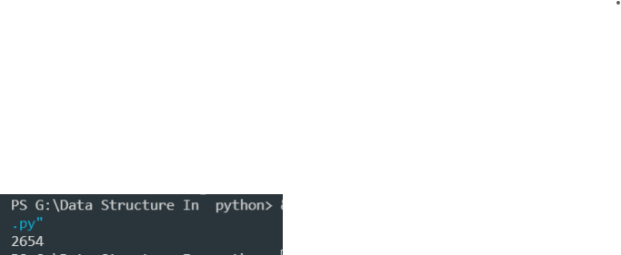

1. **Write a Program to display elements from a given list present at odd index positions.**

**Code:**

#Initialize array

arr = [1, 2, 3, 4, 5];

print("Elements of given array present on odd position: ");

for i in range(0, len(arr), 2):

print(arr[i]);

**Output:**

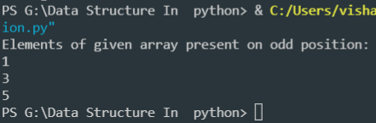

1. **Python program to check whether the given number is even or not.**

**Code:**

num = int(input("Enter a number: "))

if (num % 2) == 0:

print("{0} is Even".format(num))

else:

print("{0} is Odd".format(num))

**Output:**

1. **Python program to find the area of a triangle whose sides are given**

**Code:**

a = float(input('Enter first side: '))

b = float(input('Enter second side: '))

c = float(input('Enter third side: '))

# calculate the semi-perimeter

s = (a + b + c) / 2

# calculate the area

area = (s*(s-a)*(s-b)*(s-c)) ** 0.5

print('The area of the triangle is %0.2f' %area)

**Output**:

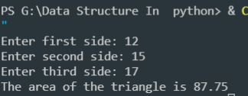

1. **Python program to find out the average of a set of integers.**

**Code:**

n=int(input("Enter the number of elements to be inserted: "))

a=[]

for i in range(0,n):

elem=int(input("Enter element: "))

a.append(elem)

avg=sum(a)/n

print("Average of elements in the list",round(avg,2))

**Output:**

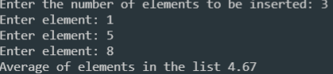

1. **Python program to check whether the given integer is a multiple of both 5 and 7.**

**Code:**

start_num = int(29)

end_num = int(36)

cnt = start_num

while cnt <= end_num:

# if number divisible by 7 and 5

if cnt % 7 == 0 and cnt % 5 == 0:

print(cnt, " is divisible by 7 and 5.")

cnt += 1

**Output:**



1. **Write a function in python to insert an element into an 1D array whose inputs are taken from the user.**

**And**

**Write a function in python to delete an element from an 1D array.**

**Code:**

lst=[]

lst_size= int(input("enter the size of list: "))

def list_entries(nlist,n):

for i in range(n):

val= int(input("enter value: "))

nlist.append(val)

print("list is : ",nlist)

loop()

def loop():

while 1:

print("1. If you want to insert element")

print("2. If you want delete element")

print("3. Exit")

choice_want(int(input("Enter your Choice: ")))

# choice case

def choice_want(choi):

if(choi==1):

insert_sp(lst,

int(input("enter a value to insert :")),

int(input("enter the position :")),lst_size)

elif(choi==2):

del_element(lst,int(input("enter the element to delete from list: ")),lst_size)

elif(choi==3):

exit(loop)

else:

print("invaild entry")

# insert element in a list

def insert_sp(lst,item,pos,no):

lst.append(None)

print("length of array:",len(lst))

for i in range(no-1,pos-2,-1):

lst[i+1]=lst[i]

lst[pos-1]=item

print("modified list", lst)

# delete element from a list

def del_element(lis,key,sze):

for i in range(sze):

if(lis[i]==key):

print("element present in this list \n******________ Successfully passed________******")

pos=i

for i in range(pos,sze-1):

lis[i]=lis[i+1]

lis.pop(sze-1)

print(key,"element del from ",i,"th position")

print("modifed list: ",lis)

break

else:

print("enter element not found in list")

# call function

list_entries(lst,lst_size)

**OutPut:**

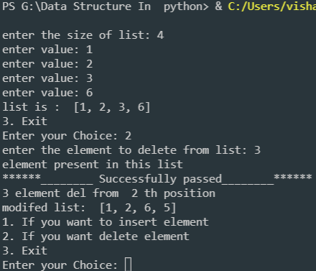

1. **Write the python code to implement Binary Search**

**Code:**

lst=[1,5,9,7,6,3]

length=len(lst)

element=int(input("Enter element to be searched for:"))

for i in range(0,length):

if element==lst[i]:

print(element,"found at index",i)

break

else:

print(element,"not found in given list")

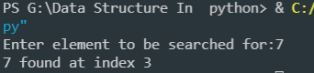**Output:**

1. **Write a python code to find the sum of two matrices**

**Code:**

X = [[1,2,3], **OutPut**:

[4 ,5,6],

[7 ,8,9]]

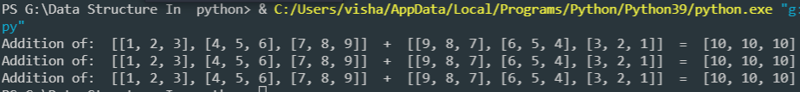Y = [[9,8,7],

[6,5,4],

[3,2,1]]

result = [[0,0,0],

[0,0,0],

[0,0,0]]

for i in range(len(X)):

for j in range(len(X[0])):

result[i][j] = X[i][j] + Y[i][j]

for r in result:

print("Addition of: ",X," + ",Y," = ",r)

1. **Write a Python code to implement Stack (Show the function of Push and Pop).**

**Code:**

a=[]

def push(a, val):

a.append(val)

print("element insert Successfully!!")

def popelement(a):

val = a.pop()

print("element poped item = ", val)

def display(a):

for i in range(len(a)-1,-1,-1):

print(a[i])

while 1:

choice = int(input("1. Push \n 2. Pop \n 3. Display \n 4. Exit \n Enter Your Choice: "))

if(choice == 1):

val =int(input("Enter the No. to Push: "))

push(a, val)

elif(choice == 2):

if len(a)==0:

print("stack is empty")

else:

popelement(a)

elif choice == 3:

if len(a)==0:

print("stack is empty")

else:

display(a)

else:

break

**Output:**

